Hénon-Heiles Hamiltonian – Chaos In 2-D

## Modeling Chaos & Complexity – 2008 Youval Dar Physics [dar@physics.ucdavis.edu](mailto:dar@physics.ucdavis.edu)

# Abstract

Chaos in two degrees of freedom, demonstrated by using the Hénon-Heiles Hamiltonian

# Introduction

A star moving about a galactic center can be considered a point mass. The Hamiltonian governing this motion will have three degrees of freedom (six coordinates in phase space) and will look like. In 1964, while investigating the motion of stars around the galactic center, Michael Hénon and Carl Heiles wanted to simplify the problem, they reduced the degrees of freedom by arguing invariant energy, angular momentum  (due to the cylindrical symmetry) supported by the observed motion that was confined to two dimensions. They chose to use a Hamiltonian that is used for motion in a near elliptic equilibrium.

In this paper I will examine Hénon and Heiles Hamiltonian dynamic properties, to some extent. In particular, I will look at the chaotic nature of the motion described by the equation of motion that derived from this Hamiltonian.

# Project’s objective

To gain an understanding of the dynamics of this specific Hamiltonian, to locate the onset of chaos and to observe what general lesson we can learn from it. To do that using computational tools learned in the course and using Python.

# Basic Analysis

The Hénon - Heiles Hamiltonian:



In Cartesian coordinates



And converting, normalizing and making dimensionless constants



This equation can be further generalized in the form



Deriving the equation of motion using



The equations of motion are



For the fixed points, we want



At the same time, so



So



We also have the condition of invariant energy which is reduced to



So our fixed points should comply with both and

The Jacobian: 



The Jacobian determinant:



The Eigen values are:



The sum of the Eigen values is zero, which is consistent with energy conservation.

For chaos in 2-torus we expect the Lyapunov Characteristic Exponents (LCE) to be (+, 0, 0,-), to find them we can diagonalize the Jacobian and then find the Eigen values or use another method.



Using the conditions from



For, for 

For  and  for 

I didn’t observe the expected  at the fixed points and I didn’t figure out why that is. For the fixed point we get the energy level which is the boundary of the potential region that allows orbits and when we are out of that region. So something is wrong here…

I want to note two interesting points in equation , is the limit of the energy above which we get no orbit. And the solution of indicates the range of possible values of and at those points we get elliptical orbit, elliptic in phase space oscillating through the center in space.

# General visualization approach

My plan was to create graphical analysis tools and then probe the system. The graphical tool I wanted to build should have produced Poincaré plots for different intersecting planes, 3-D phase space plots, capability to plot a single path and an evolution of array of initial conditions, to plot 2-D plots, to calculate Lyapunov exponents, Entropy rate  and finally to evaluate what percentage of the solution space is chaotic. I started to work on that plan but had to significantly reduce my goals in order for this project to be completed on time. (The mid-way change of plan shows in the python program flow.)

# Computational strategy

After choosing some initial conditions, I will use equations , integrate them using Runga-Kutta method and use equation to make sure that we keep the condition of energy conservation, making sure not to accumulate error due to the numerical calculation.



To get the Poincaré I will look at an intersection of the chosen 3-D phase space solution with the plane



(In the actual program I reduced it to the plane only.)



The plan for error correction was to check the error of a certain number of iterations and randomly apply correction to one of the four phase space coordinates. I planned to do it this way in order to avoid over-correcting one coordinate. In practice, due to time limitations, I just monitored the numerical error and since it never went over I never applied corrections (the correction functions, though not use are in the program).

# Looking at our potential

Potential equipotentials lines, the straight lines are for  and the smaller closed curves are for a smaller. Note the symmetry of the potential. Recall the results of the Jacobian determinant.

  

Finding extremums by finding where the first derivatives are zero and then using the descriminant







The extremum points I found were: 

Using the descriminant point (0, 0) is a relative minimum and the rest are saddle points. So we can expect orbital motion to exit only in the area within the triangle created by the points . When going out of that area the trajectory just runs away. (This can be verified by the program.)

# Chaotic region

The Poincaré plots together with the 3-D phase space picture are very useful in understanding what is going on. By playing with the initial conditions it looks like the onset of chaos is around. When the energy was  we got non-chaotic orbits, though some were very complex. It looks like we have an elliptical orbit on the edge of possible solutions for the equations. (I did not investigate it enough to see when we get period doubling). But, we could qualitatively observe how the chaotic region, in the solution space, is getting bigger with when.

# e=1-12 array v2.png

Figure : poincaré plot of 15 initial conditions  
Dimentionless energy, e=1/12, non-chaotic orbis

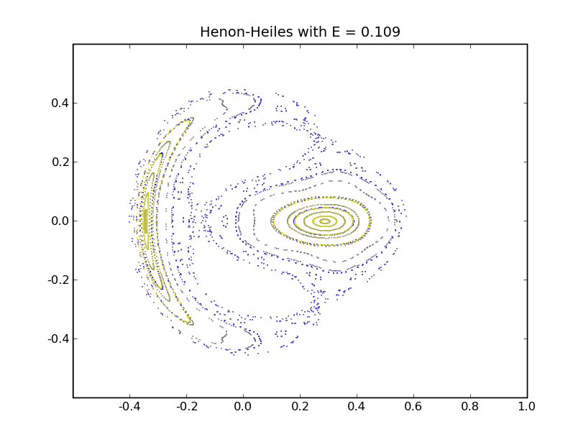

Figure : E = 1/9.1   
More complex picture but still no chaotic regions

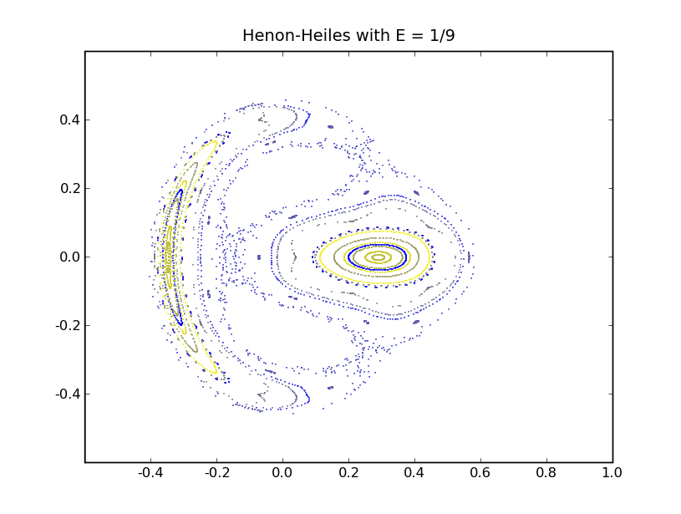

Figure : Chaotic regions starting to appear

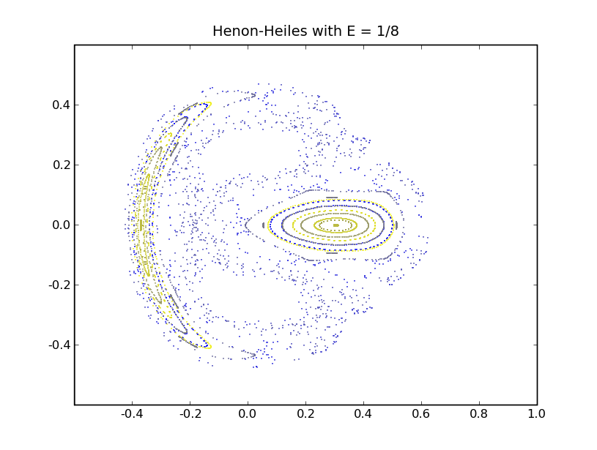

Figure : very chaotic

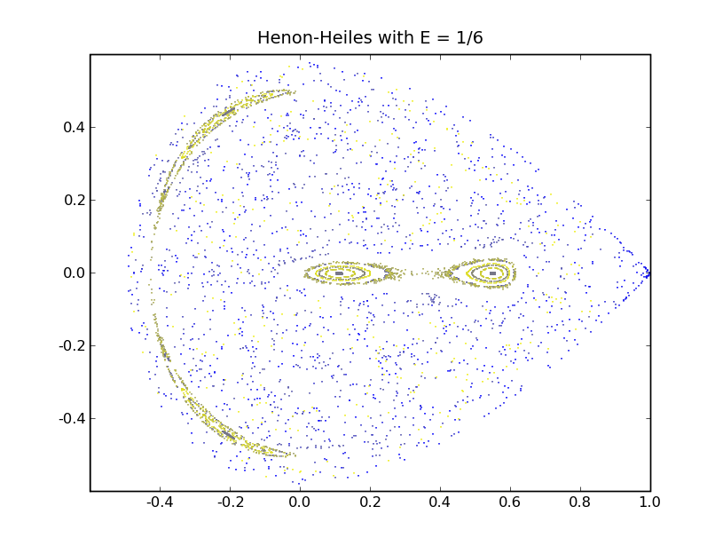

Figure : mostly chaotic

# Screen shots of some 3-D phase space plots

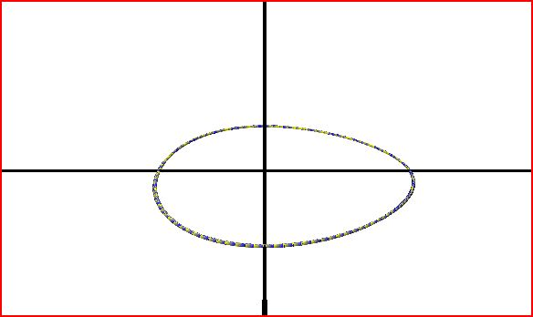

Figure : e=1/2,   
Eliptical orbit in phase space, is a bifuracation point  
The color indicates the age of the curve

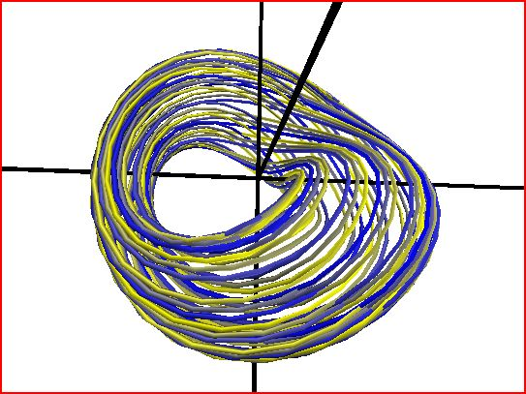

Figure : E=1/12,   
Still non-chaotic region  
The color indicates the age of the curve

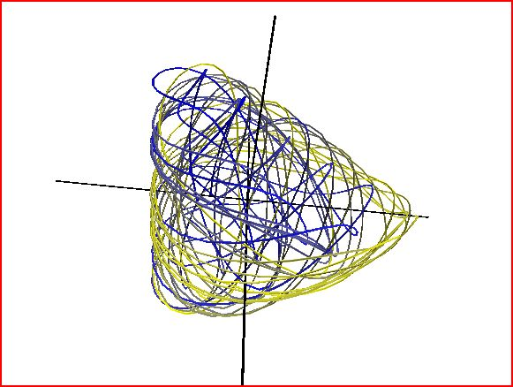

Figure : e=1/6,   
chaotic orbit

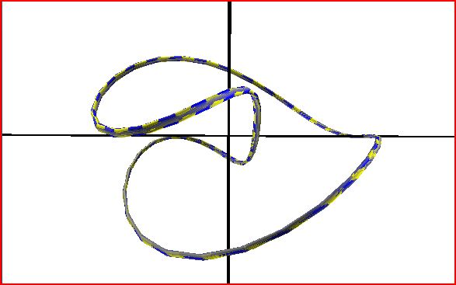

Figure : E=1/6,   
non-chaotic orbit in mostly chaotic landscape

# Project conclusions

The onset of chaos for this system was approximately. I found it by looking at the Poincaré maps and trying different energies.

Poincaré is a great tool to look at a system that has three independent coordinates; it is simple, and together with the 3D plots, very helpful in getting some intuition and basic analysis for the system dynamics.

When planning a project, if you have more realistic goals you can achieve more. I spent too much time thinking how to write the program to be more general and flexible, and at the end had to cut it in order to get results which left the program messy and left many interesting quantities not explored.

# Program algorithms I did not include in the program

Multi-plane intersection

The way I thought to allow intersecting the 3D phase space with any plane was, to rotate the coordinate system in a way that the intersecting plane will be at, this, I thought, will make it much easier to determine when the curve crosses the intersection plane.

The algorithm:



* Rotating to the new coordinate system
* Checking and collecting the points where changes sign
* Printing 

Lyapunov Exponents

Following the idea that the orthonormal vectors tangent to the curve are the quantities we need to follow

* Define all the derivative equations, , 4-D phase space 4 equations
* Initialize the vectors 
* Iterate the equations and find the new vector length, ,(this is an indication of stretching or contracting in a certain direction)
* 
* Now use the Gramm-Schmit process to make the new set of vectors orthonormal again.
* Repeat for as many iterations as desired and at the end do 

This process is taken from the example python programs.

# Bibliography

1. Jim Crutchfield lecture notes for the course Modeling Chaos & Complexity – 2008
2. Strogatz, Nonlinear Dynamics and Chaos
3. James D. Meiss, Differential Dynamical Systems
4. Goldstein Poole & Safko, Classical Mechanics
5. http://mathworld.wolfram.com/Henon-HeilesEquation.html