Cellular Automata Model for Epidemics

Sharon Chang
UC Davis Physics
shschang@ucdavis.edu

Cellular automata models are used to simulate the spread of disease across a population. Two types of infections are examined here: disease where individuals become immune to the disease and the common cold where individuals are only “immune” to the disease for a short period before becoming susceptible again. A small increase in the probability of an individual infecting a healthy neighbor increases the number of individuals infected and the rate at which the disease spreads by a greater amount than a small decrease in the recovery rate.
Introduction

An unfortunate side effect of urban living involves the risk of the spread of a highly contagious disease. Studying how a disease will spread can allow ample time for preventative measures to be taken. This project will visually display how a disease spreads spatially across a population through a cellular automata model. A population consists of a grid of cells, which can each have three states: susceptible, infected, or recovered. Cells susceptible to the disease have not yet had the disease, and may be infected by its neighbors. Cells that are infected may transmit the disease to its neighbors. Cells that are recovered are no longer infectious to its neighbors. This project also examines the spread of the common cold, where recovered populations become susceptible again after a set amount of time. The probability of a cell transmitting the disease to another cell (transmit probability) and the probability of a cell recovering (recovery probability) was varied to determine which parameter has a greater impact on the rate at which the disease spreads.

Background

Cellular automata models consist of cells on a grid that may change colors at discreet times to represent different states. A cell’s state is determined by a set of rules and the state of its neighbors, and therefore the neighborhood of a cell must be specified. This project studies two-dimensional cellular automata models, an example of which is Conway’s game of life. Cellular automata have long been used to study biological systems such as this project does^{1,2}.

Dynamical System

The Kermack-McKendrick model for infectious disease consists of three coupled nonlinear ordinary differential equations^{3,4}:

dS | = -βSI | 1
dt | = -βSI | 1
dI | = βSI – γI | 2
dt | = βSI – γI | 2
dR | = γI | 3
dt | = γI | 3

where S is the number of individuals susceptible to the disease, I is the number of individuals infected with the disease, and R is the number of individuals recovered. β is the infection rate, and γ is the recovery rate. The Kermack-McKendrick model assumes a constant population size, no incubation period, and the period in which one is infectious is the same as the disease. Figure 1 shows the ODEs for the Kermack-McKendrick model plotted as a function of time.

Methods

The cellular automaton model is based on the Kermack-McKendrick model. Each cell will have a certain probability of becoming infected:

P_{infect} = 1 – (1 – p)^{R} 4

where p is the probability that a infected cell will transmit the disease to a healthy cell, and R is the number of cells surrounding the healthy cell. Each cell will also have a certain probability of recovering from the disease:

P_{recover} = q 5

and the values of p and q are between 0 and 1. P_{infect} and P_{recovered} are then compared to random numbers. If the probability is more than the random number, then the cell will become infected or will recover, otherwise the cell will stay in the same state. For the common cold, cells that are recovered will become susceptible again after a set amount of updates⁵. The neighborhood used in this project is the Moore Neighborhood. The number of neighbors, n, around a cell is given by the following equation:

n = (2r + 1)² 6

where r is the range⁶. This project uses a Moore Neighborhood with range 1, giving nine possible neighbors for each cell.
The state of each cell will be updated accordingly and displayed with the following colors: green if the cell is susceptible, red if the cell is infected, and black if the cell is recovered. The number of susceptible, infected, and recovered cells is then plotted as a function of time.

Results

Each simulation (figures 2 through 4) was run with an initial infected population of 100 and a 150x150 cell grid for a total population of 22500. At p=0.3 (figure 4) the model starts to deviate from the Kermack-McKendrick model, since there is a significant jump in the number of infected individuals at the beginning of the epidemic. Therefore, the values of p and q will be varied centered on p = 0.2 and q = 0.5 (figure 3).
If the value of p is raised from 0.2 to 0.25 while the value of q remains at 0.5, there is a clear increase in the number of infected individuals compared to p = 0.2 (figure 5). However, if the value of p is kept at 0.2 and the value of q is lowered to 0.45, the highest number of infected individuals in time is less than that for when p was raised (figure 6). It is also apparent that the rate at which individuals are infected for the changed q is lower than that for the changed p. Therefore, raising p leads to a longer lasting infection that affects a greater number of people at the height of the epidemic than lowering q by the same amount.
For the model for the common cold, each of the following simulations (figures 7 through 9) were also run with an initial infected population of 100 and a 150x150 cell grid. A cell will stay recovered for 10 updates, and then they become susceptible again. The number of susceptible, infected, and recovered individuals is plotted as a function of time for various values of p while q is kept at 0.3. At p = 0.15 (figure 7), there seems to be mostly random increases and decreases in the graph. For p = 0.17 and p = 0.2, it is apparent that there are periodic oscillations in the susceptible, infected, and recovered populations. If the value of p is increased, the amplitude and frequency of the oscillations increases, meaning a greater number of individuals are becoming infected in a shorter amount of time. The oscillations all eventually become small random increases and decreases in the graph, but are centered about a constant percentage of the total population. Figure 10 shows the change of the cellular automata distribution as time increases. At t = 0, the initial distribution of infected individuals is shown. As time progresses, it is apparent how quickly the patches of recovered individuals become randomly distributed throughout the population. However, when the time an individual spends as recovered is increased to 29 updates, the infection dies out completely, since time it takes for cells to become susceptible again is longer than the time it takes for all infected cells to recover.

Conclusion

By increasing p, it is evident that a small change in p can lead to a longer epidemic with larger number of individuals suffering from the disease. Yet a decrease in q does not have as large of an effect on the epidemic as an increase in p by the same amount. This leads to the conclusion that a deadlier epidemic depends more on how quickly the disease spreads rather than how quickly the individual recovers.
The model for the common cold displayed periodic behavior not seen in the SIR model. When the length of “immunity” is long enough for this model, the epidemic dies out. This is consistent with the rise and fall of “flu season” we see in society.
Although the Kermack-McKendrick model is a highly simplified model, changes may be made to the model to account for factors such as birth, death and spatial structure that make the model more realistic. Models such as these may help authorities take necessary precautions when a disease outbreak is suspected, as well as explain the outcome of past epidemics.

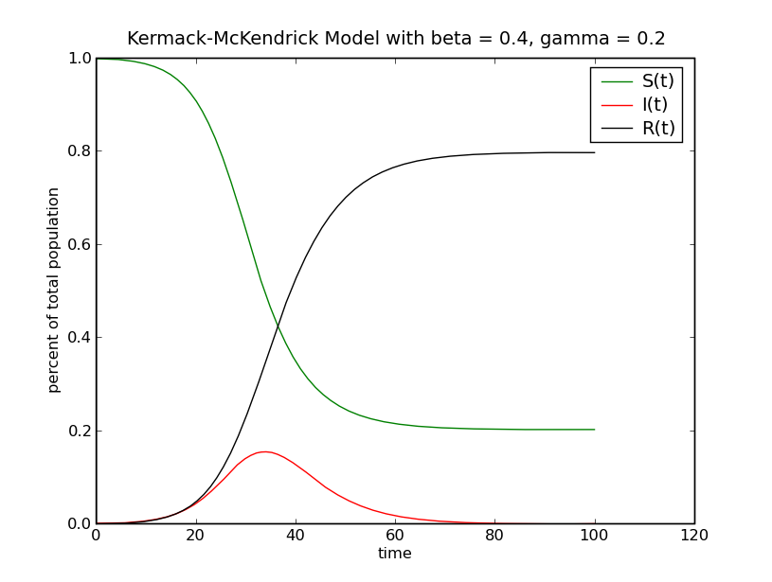
Figure 1: Kermack-McKendrick model using values β = 0.4 and γ = 0.2, with initial infected population 100 and population size 22500

Figure 2: Percent of total population of susceptible, infected, and recovered individuals for the cellular automata SIR model with respect to time, averaged over 10 simulations. Initial infected population of 100, population size 150x150 grid, p = 0.1 and q = 0.5.

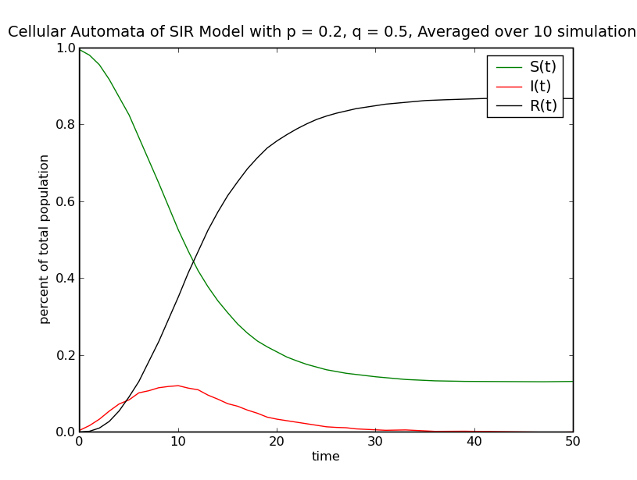

Figure 3: Percent of total population of susceptible, infected, and recovered individuals for the cellular automata SIR model with respect to time, averaged over 10 simulations. Initial infected population of 100, population size 150x150 grid, p = 0.2 and q = 0.5.

Figure 4: Percent of total population of susceptible, infected, and recovered individuals for the cellular automata SIR model with respect to time, averaged over 10 simulations. Initial infected population of 100, population size 150x150 grid, p = 0.3 and q = 0.5.

Figure 5: Percent of total population of susceptible, infected, and recovered individuals for the cellular automata SIR model with respect to time. Initial infected population of 100, population size 150x150 grid, p = 0.25 and q = 0.5.

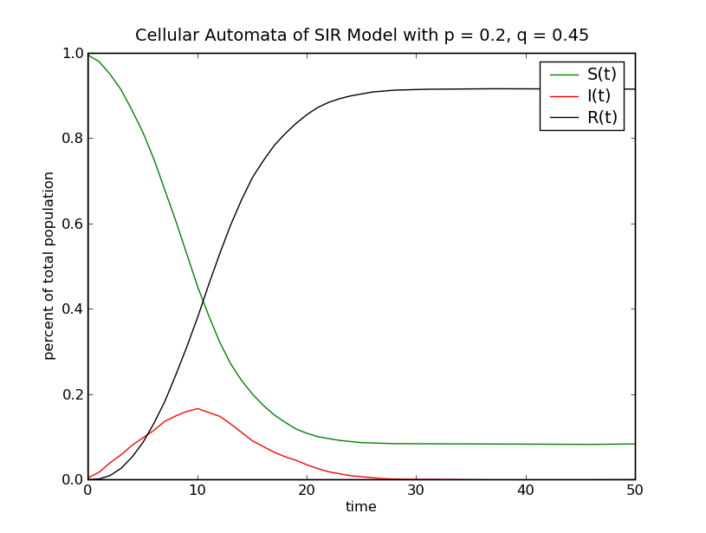
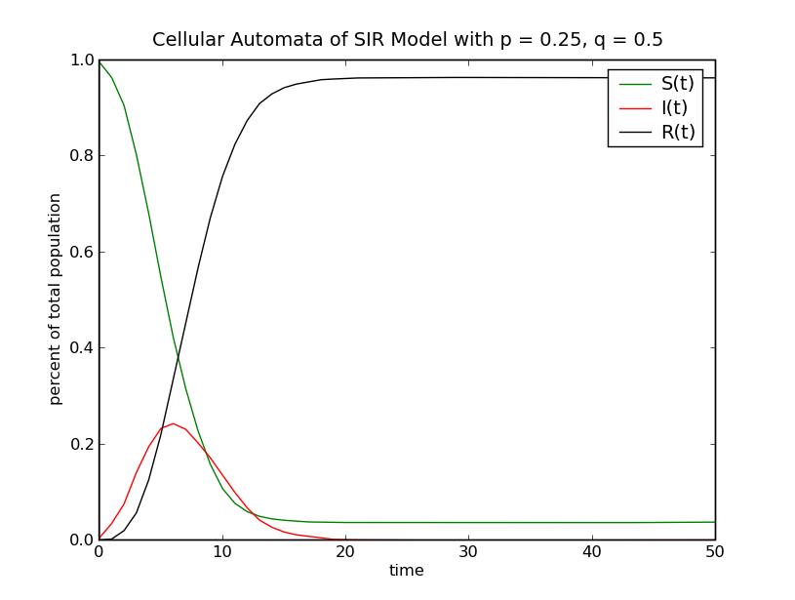
Figure 6: Percent of total population of susceptible, infected, and recovered individuals for the cellular automata SIR model with respect to time. Initial infected population of 100, population size 150x150 grid, p = 0.2 and q = 0.45.

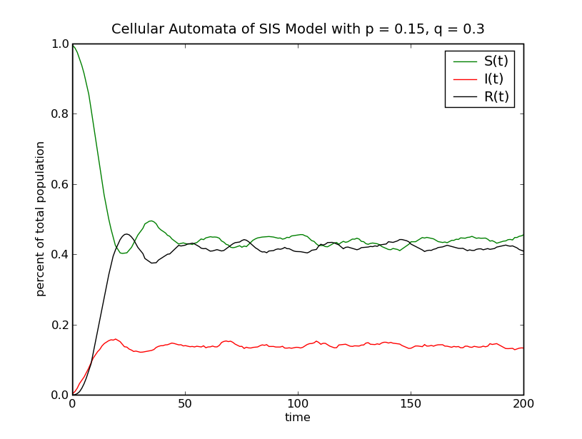
Figure 7: Percent of total population of susceptible, infected, and recovered individuals for the cellular automata model for the common cold with respect to time. Initial infected population of 100, population size 150x150 grid, p = 0.15 and q = 0.3

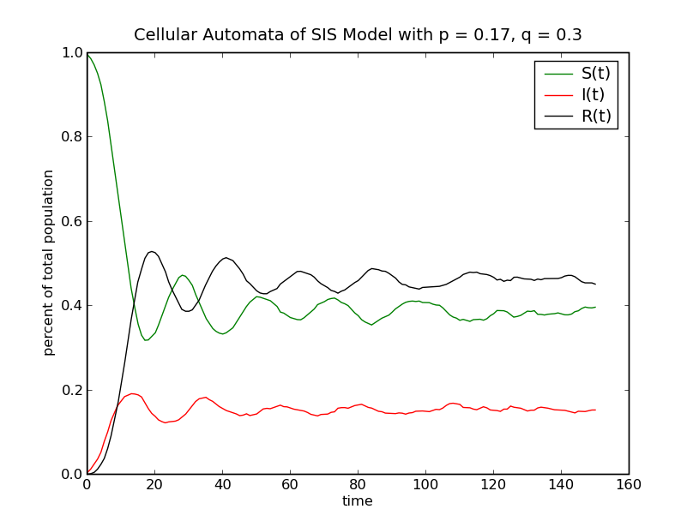

Figure 8: Percent of total population of susceptible, infected, and recovered individuals for the cellular automata model for the common cold with respect to time. Initial infected population of 100, population size 150x150 grid, p = 0.17 and q = 0.3

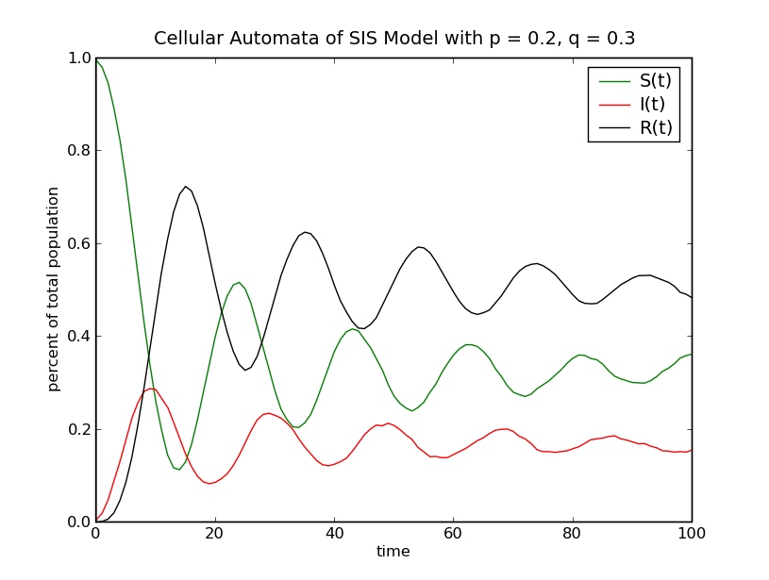
Figure 9: Percent of total population of susceptible, infected, and recovered individuals for the cellular automata model for the common cold with respect to time. Initial infected population of 100, population size 150x150 grid, p = 0.2 and q = 0.3

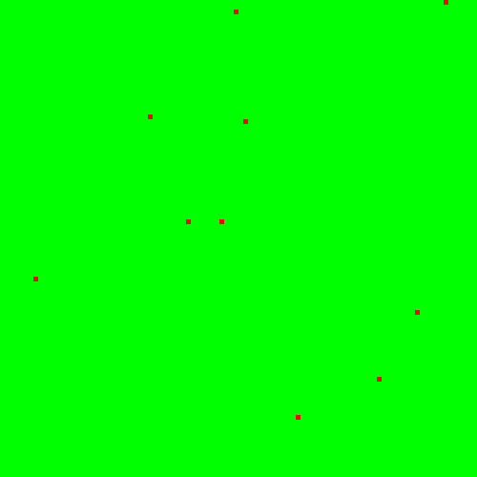
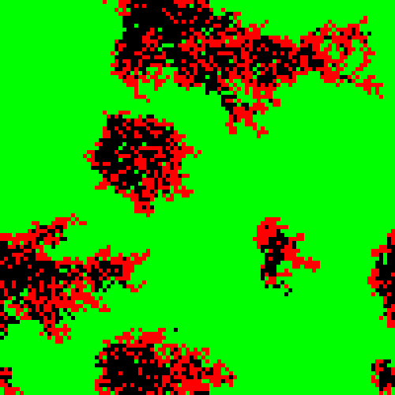
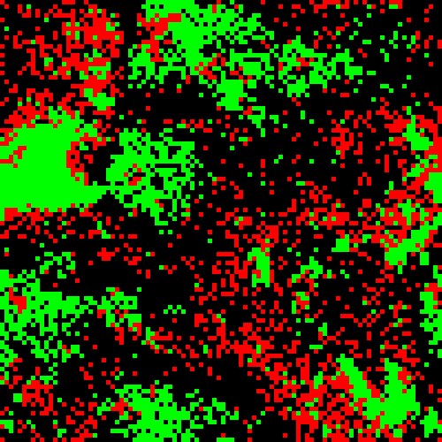
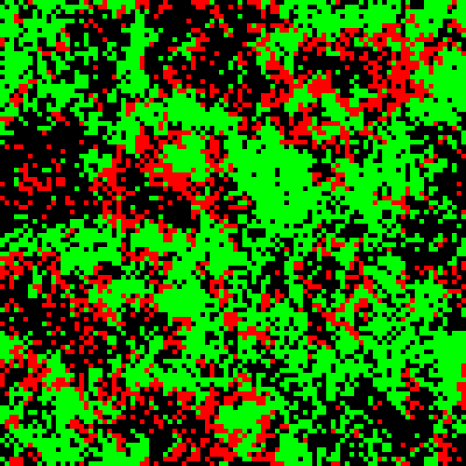
a) t = 0
b) t = 10
c) t = 20
d) t = 30
Figure 10: Cellular automata distribution at: a) time t=0; b) t=10; c) t=20; d) t=30 for the common cold. It is apparent how rapid the spots of infectivity become randomly distributed

Bibliography

1. S.C. Fu and G. Milne. Epidemic modelling using cellular automata. In Proceedings of the 1st Australian Conference on Artificial Life (ACAL’03), Canberra, December 2003.
2. E.W. Weisstein. Kermack-McKendrick Model. From MathWorld—A Wolfram Web Resource. http://mathworld.wolfram.com/MooreNeighborhood.html

3. W.O. Kermack and A.G. McKendrick. A Contribution to the Mathematical Theory of Epidemics. Proceedings of the Royal Society of London, 115 (1927): 700-721

4. J. Satsuma, R. Willox, A. Ramani, B. Grammaticos, and A. S. Carstea. Extending the SIR Epidemic Model. Physica A: Statistical and Theoretical Physics, 336.3-4 (15 May 2004): 369-375

5. S. Venkatachalam and A.R. Mikler. An Infectious Disease Outbreak Simulator Based on the Cellular Automata Paradigm. Lecture Notes in Computer Science, 3473 (2006): 198-211

6. E.W Weisstein. Moore Neighborhood. From MathWorld—A Wolfram Web Resource. http://mathworld.wolfram.com/MooreNeighborhood.html

